Voice Traffic

🗣️ What Is Voice Traffic in Networking?
# Source: AI Source: Provided by: [Data Path: Persons Table -> ID Column: 1, Name_En Column: Motasem Essam] -> From: [ChatGPT] on [12/15/2025]
Voice traffic refers to digital audio signals (usually human speech) transmitted over a network — especially in VoIP (Voice over IP) systems. It is real-time communication data that must be delivered quickly and consistently to maintain conversation quality.

🧠 Simple Definition:
# Source: AI Source: Provided by: [Data Path: Persons Table -> ID Column: 1, Name_En Column: Motasem Essam] -> From: [ChatGPT] on [12/15/2025]
Voice traffic is the flow of voice data packets across a network, used in phone calls, video conferencing, or voice messaging over IP-based systems.

📦 Belongs to:
# Source: AI Source: Provided by: [Data Path: Persons Table -> ID Column: 1, Name_En Column: Motasem Essam] -> From: [ChatGPT] on [12/15/2025]
✅ Real-Time Network Traffic
Alongside video traffic, gaming, and live streaming

📡 Common Sources of Voice Traffic
# Source: AI Source: Provided by: [Data Path: Persons Table -> ID Column: 1, Name_En Column: Motasem Essam] -> From: [ChatGPT] on [12/15/2025]
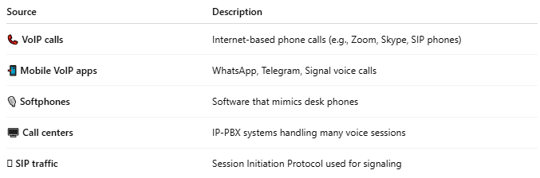

Source | Description
📞 VoIP calls | Internet-based phone calls (e.g., Zoom, Skype, SIP phones)
📲 Mobile VoIP apps | WhatsApp, Telegram, Signal voice calls
🎙 Softphones | Software that mimics desk phones
🖥️ Call centers | IP-PBX systems handling many voice sessions
🛜 SIP traffic | Session Initiation Protocol used for signaling

🧊 Special Characteristics of Voice Traffic
# Source: AI Source: Provided by: [Data Path: Persons Table -> ID Column: 1, Name_En Column: Motasem Essam] -> From: [ChatGPT] on [12/15/2025]
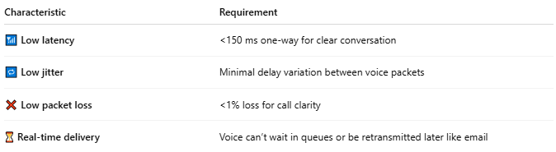

Characteristic | Requirement
📶 Low latency | <150 ms one-way for clear conversation
🔁 Low jitter | Minimal delay variation between voice packets
❌ Low packet loss | <1% loss for call clarity
⏳ Real-time delivery | Voice can’t wait in queues or be retransmitted later like email

📦 Voice Packet Format
# Source: AI Source: Provided by: [Data Path: Persons Table -> ID Column: 1, Name_En Column: Motasem Essam] -> From: [ChatGPT] on [12/15/2025]
- Codec: Converts voice into digital format (e.g., G.711, G.729, Opus)
- Protocol stack:
  - RTP (Real-time Transport Protocol) → carries audio
  - UDP → fast, no retransmission
  - IP → routes the packet

🚦 Prioritizing Voice Traffic
# Source: AI Source: Provided by: [Data Path: Persons Table -> ID Column: 1, Name_En Column: Motasem Essam] -> From: [ChatGPT] on [12/15/2025]
To ensure good call quality, networks often use:
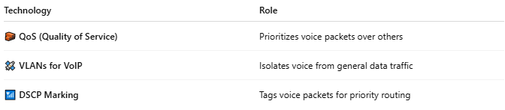
Technology | Role
🧱 QoS (Quality of Service) | Prioritizes voice packets over others
🛰️ VLANs for VoIP | Isolates voice from general data traffic
📶 DSCP Marking | Tags voice packets for priority routing

🧪 How to Monitor Voice Traffic
# Source: AI Source: Provided by: [Data Path: Persons Table -> ID Column: 1, Name_En Column: Motasem Essam] -> From: [ChatGPT] on [12/15/2025]
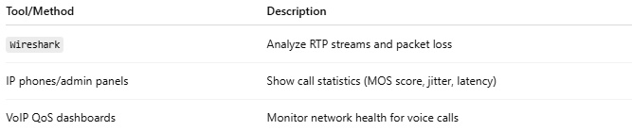

Tool/Method | Description
Wireshark | Analyze RTP streams and packet loss
IP phones/admin panels | Show call statistics (MOS score, jitter, latency)
VoIP QoS dashboards | Monitor network health for voice calls

📌 Summary
# Source: AI Source: Provided by: [Data Path: Persons Table -> ID Column: 1, Name_En Column: Motasem Essam] -> From: [ChatGPT] on [12/15/2025]
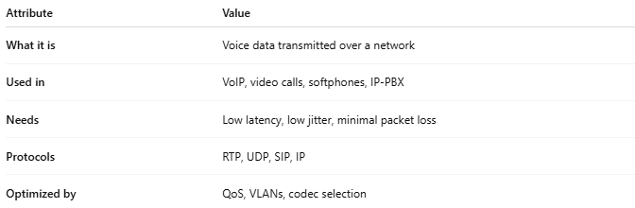

Attribute | Value
What it is | Voice data transmitted over a network
Used in | VoIP, video calls, softphones, IP-PBX
Needs | Low latency, low jitter, minimal packet loss
Protocols | RTP, UDP, SIP, IP
Optimized by | QoS, VLANs, codec selection

